**Exercise: Using time intelligence to compare to previous year**

**Introduction**

You should now understand the fundamentals of DAX and time intelligence at this lesson stage.

This exercise asks you to apply your knowledge of these concepts by creating measures using DAX expressions in Power BI.

By completing this exercise, you will demonstrate your ability to:

* Create measures to compare Adventure Works' year-over-year sales growth.
* Form measures for an appropriate data type.
* Create a matrix to view the results of the time intelligence comparison.

**Scenario**

Adventure Works needs to analyze the performance of its sales team and growth to plan for the next financial year. The company needs your help to generate the insights required to build this business plan.

Begin by helping Adventure Worksto evaluate its sales from the previous year to compare the sales team's performance for the current year. Then calculate Adventure Works' year-over-year change in sales to analyze the company’s growth and monthly and annual trends in sales volume.

Adventure Works provides a Power BI project file called *AdventureWorks.pbix* that contains the required data model. You must load this dataset into Power BI, evaluate the data quality, and configure the model to ensure that Adventure Works can use it to make informed decisions.

[Adventure Works](https://d3c33hcgiwev3.cloudfront.net/1NuaH6reSva44Wjr5oljGQ_8aef9775648448fba427bbed240776f1_Adventure-Works.pbix?Expires=1711152000&Signature=JbdMcXE~dXthY1lQc14o9xn66wF1TjRddK9qnHOw5MENprdOJjDL3RmTT2HfGmBQrk0b3plg3MrDC9~BNf7QMg571~l2SrZq0yT81lnjgaqWzTnaoBX9Ryqd-W1zHiSkJPZb7LLsLugqTgnh6VRrkocN1pWw4E9QQ5ErreSIwrI_&Key-Pair-Id=APKAJLTNE6QMUY6HBC5A" \t "_blank)

[PBIX File](https://d3c33hcgiwev3.cloudfront.net/1NuaH6reSva44Wjr5oljGQ_8aef9775648448fba427bbed240776f1_Adventure-Works.pbix?Expires=1711152000&Signature=JbdMcXE~dXthY1lQc14o9xn66wF1TjRddK9qnHOw5MENprdOJjDL3RmTT2HfGmBQrk0b3plg3MrDC9~BNf7QMg571~l2SrZq0yT81lnjgaqWzTnaoBX9Ryqd-W1zHiSkJPZb7LLsLugqTgnh6VRrkocN1pWw4E9QQ5ErreSIwrI_&Key-Pair-Id=APKAJLTNE6QMUY6HBC5A" \t "_blank)

**Instructions**

Create a new Power BI project called *Exercise - Using Time Intelligence to compare to the previous year*. Follow the steps below to complete the exercise.

**Step 1: Download the Adventure Works Power BI project.**

1. Download and save the Excel workbook **Adventure Works.pbix**. The Power BI data model contains five tables of data: **Sales**, **Products**, **Region**, and **Salesperson**.

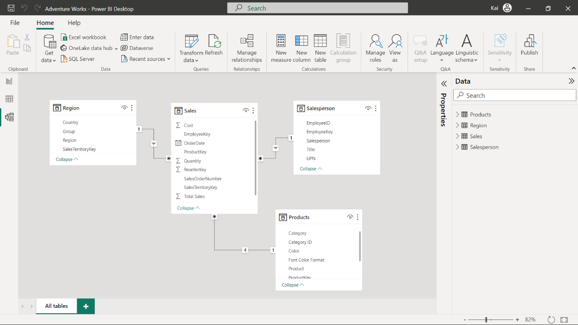

1. Load the data from the Excel sheet into Power BI. Ensure you load all tables in the workbook.
2. Open a preview of the table in the **Preview** pane.

**Tip:** You can import data using the **Get Data** drop-down menu.

**Step 2: Create the Revenue measure.**

1. Once the data is loaded into the data model, create a new measure called **Revenue**. You need to use the **Total Sales** column from the **Sales** table and the **Quantity** column from the **Date** table. You’ll use this measure to complete the remaining steps in this exercise.
2. Format the measure as **currency** data type within two decimal places.

**Tip:** You can create this measure by using the DAX **SUMX** function.

**Step 3: Create the previous year’s and year-over-year revenue changes using DAX query.**

1. Create an additional measure in the sales table for the previous year’s sales called **RevenuePY** by writing a DAX expression using a time intelligence function.
2. Format the measure as **currency** data type within two decimal places.

**Tip:** You can create this measure using the **SAMEPERIODLASTYEAR** DAX function inside the **CALCULATE** in the formula bar of the Power BI desktop interface. You can also use variables to write your DAX expression.

1. Create a measure called **Revenue YoY** to evaluate the year-over-year change in sales for Adventure Works.
2. Format the measure as a **percentage** data type within two decimal places.

**Tip:** You can modify the previous year's measure using the **DIVIDE** function in DAX.

**Step 4: Update the matrix in Power BI to view the results of the measures.**

1. Update the matrix in Power BI desktop report view by bringing **revenue**, **previous year revenue** and **revenue year-over year** change to the matrix against **months** and **year**.

**Tip:** You can access a premade matrix by navigating to Power BI’s **Report view**.

1. Note the values in all columns of the matrix/table.

**Step 5: Save the Power BI project.**

* Save your Power BI project to your local computer.

**Tip:** Make sure you select an appropriate project name and folder path.

**Conclusion**

With these steps, you have successfully created measures to help Adventure Works analyze its data based on its analytical and business requirements and proven your capabilities with time intelligence functions.

Remember that when using DAX formulas, always ensure they are correctly formatted and that the column names match the actual column names in your data.

**Exemplar: Using time intelligence to compare to previous year**

**Overview**

In the exercise *Using time intelligence to compare to previous year,* you were asked to create and format two measures using time intelligence DAX functions to help Adventure Works compare its sales.

Your tasks in this exercise were to:

* Download and connect to a dataset and review the model.
* Create two measures using DAX expressions.
* Create a matrix in Power BI to view the results of the measures.

This reading provides you with a step-by-step guide for completing these tasks. It also includes screenshots that you can compare against your work.

You can also review *Creating quick measures and creating custom measures with DAX*.

**Step 1: Download and connect to the Adventure Works dataset.**

1. Download and save the Excel workbook **Adventure Works Date.pbix** from the exercise page on the Coursera platform.

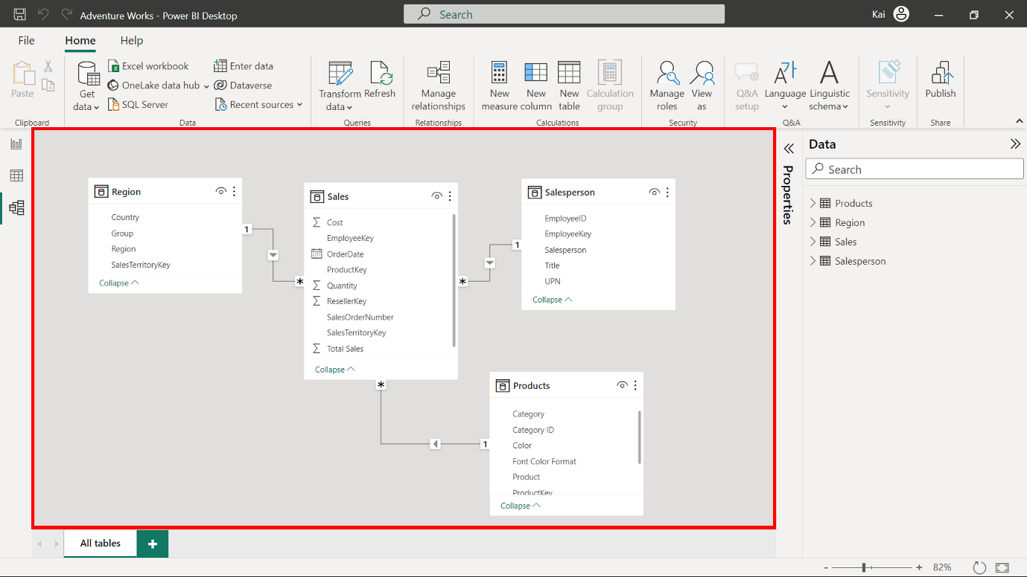

1. Load the data from the Excel Workbook in Power BI.
2. Select the Preview pane to open a preview of the table.

**Step 2: Create the Revenue measure.**

1. To create the revenue measure within your data model, you need to use the **Total Sales** column from the **Sales** table and the **Quantity** column from the **Date** table as follows:

1

Revenue = SUMX ( Sales, Sales[Unit Price] \* Sales[Quantity])

* In this measure, the **SUMX** function computes the **Total sales** by multiplying the **Unit price** by the **Quantity** column of the **Sales** table.

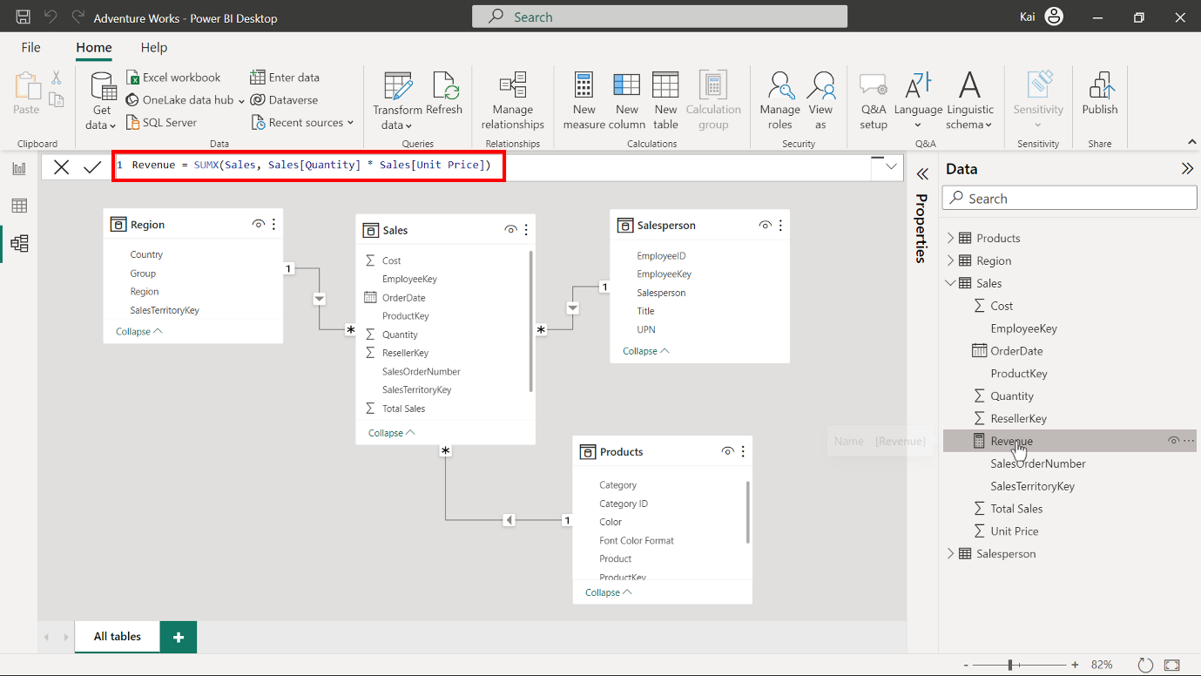

1. To format the measure, select the newly created measure from the **Data** pane. Then navigate to the **Format** group in the **Measure tools** tab of Power BI. Select **Currency** from the **Format** drop-down menu.

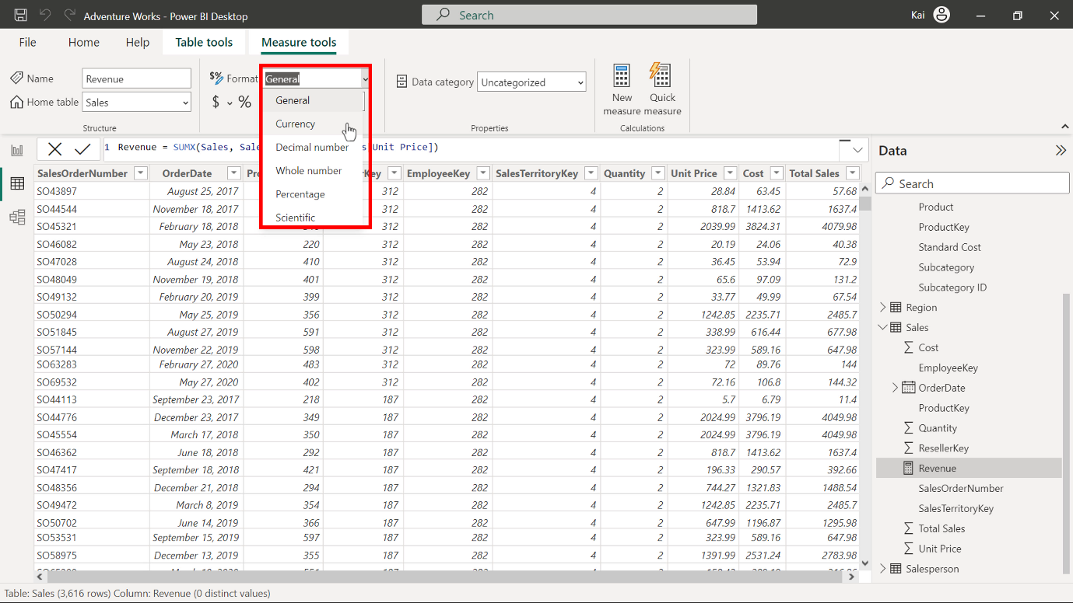

Enter **2** in the decimal places (currently **Auto** by default). This action formats the measure as a **currency** data type within two decimal places. This is best practice for visualization purposes.

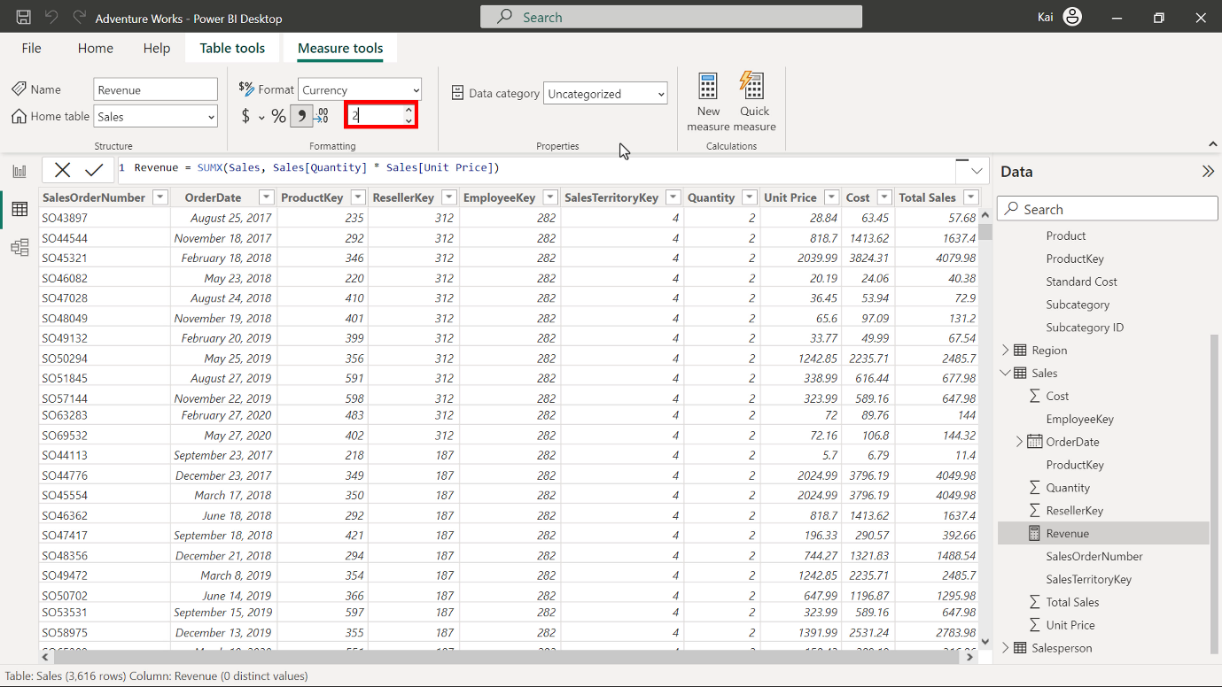

**Step 3: Create the previous year’s and year-over-year revenue changes using DAX query.**

1. To create a new measure named **RevenuePY**, access the **Data** view. Under the **Date** pane, select the **Sales** table. Then select **New measure** from the **Calculations** group to expand the DAX formula bar. Add the following DAX expression to compute the **RevenuePY** measure.

1

2

3

4

5

Revenue PY =

VAR RevenuePreviousYear =

    CALCULATE ([Revenue], SAMEPERIODLASTYEAR (Sales[OrderDate].[Date]))

RETURN

RevenuePreviousYear

* **VAR** is the variable defined for the previous year’s revenue.
* **CALCULATE** computes the total revenue using the **SAMEPERIODLASTYEAR** function, which uses the **Date** column from the **Sales** table as a parameter.
* **Revenue** in the square brackets is the previous measure you created.
* **RETURN** displays the value of the entire expression.

Once you execute the code, the **Revenue PY** measure appears in the **Data** pane under the **Sales** table.

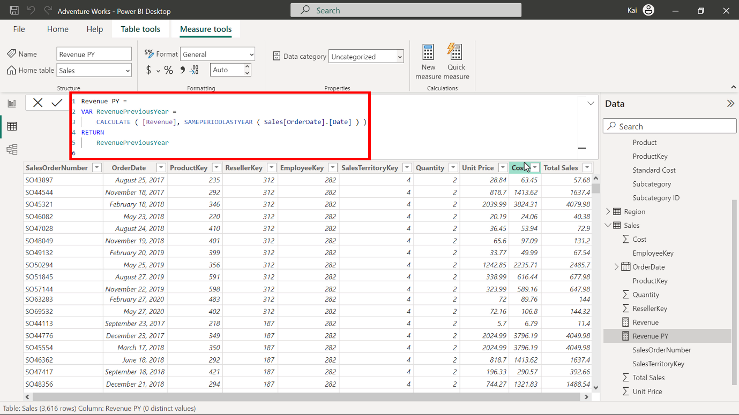

1. To format the new measure, select it from the data pane. Then navigate to the **Formatting** group in the **Measure tools** tab of Power BI. Select **currency** data type from the **Format** drop-down menu. Enter a value of **2** in the decimal place field (currently **Auto** by default). This action formats the measure as **Currency** data type within two decimal places and is good for visualization. You can view the results of the measure in the following diagram.

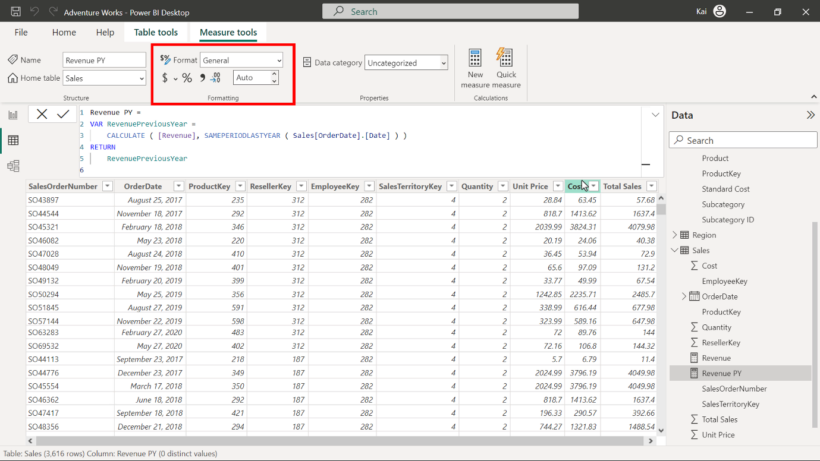

1. Repeat this process to create a new measure named **Revenue YoY %** using the following DAX code:

1

2

3

4

5

Revenue YoY % =

VAR RevenuePreviousYear =

    CALCULATE ([Revenue], SAMEPERIODLASTYEAR (Sales[OrderDate].[Date]))

RETURN

    DIVIDE ([Revenue] - RevenuePreviousYear, RevenuePreviousYear)

* In the above expression, in addition to the previous calculation, the **DIVIDE** function computes the change ratio of **Sales** by dividing the difference of the current year’s revenue by the previous year's revenue.

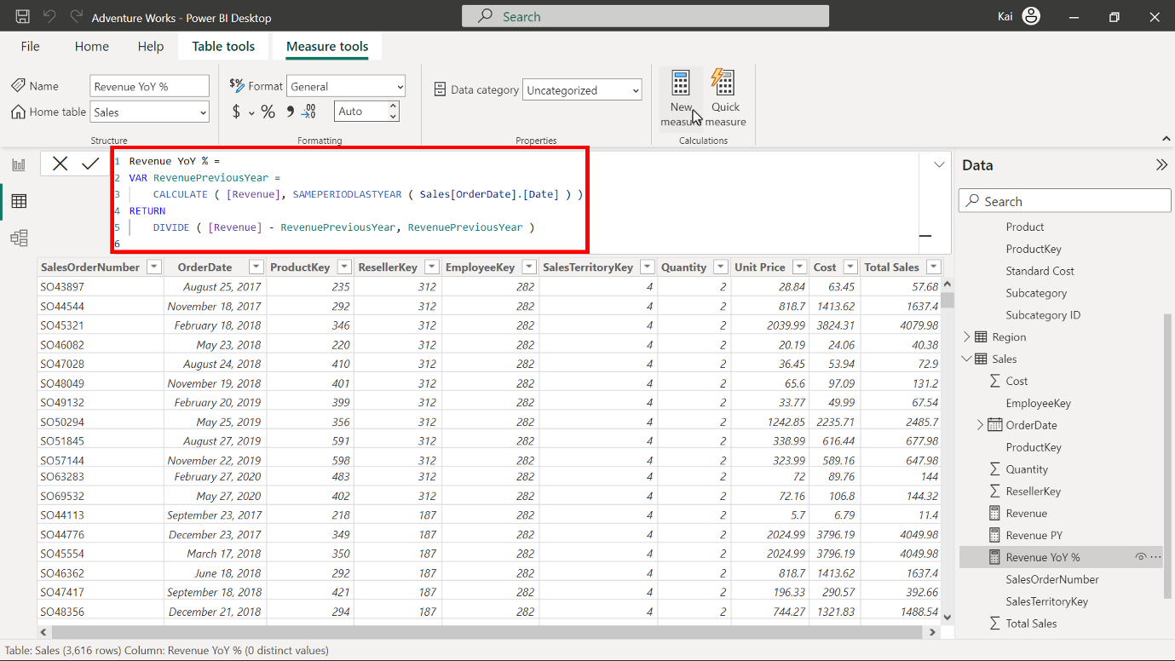

1. Repeat the formatting process from step 2. In this instance, remember to select **Percentage** instead of **Currency**.

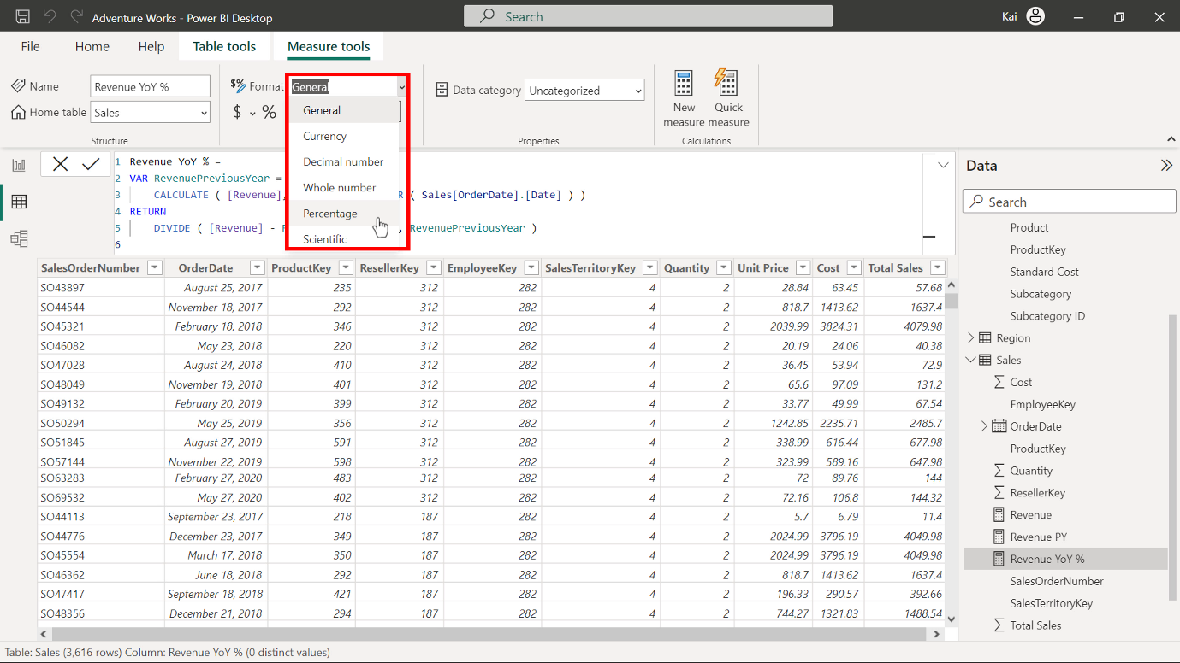

Enter a value of **2** in the **decimal place** field.

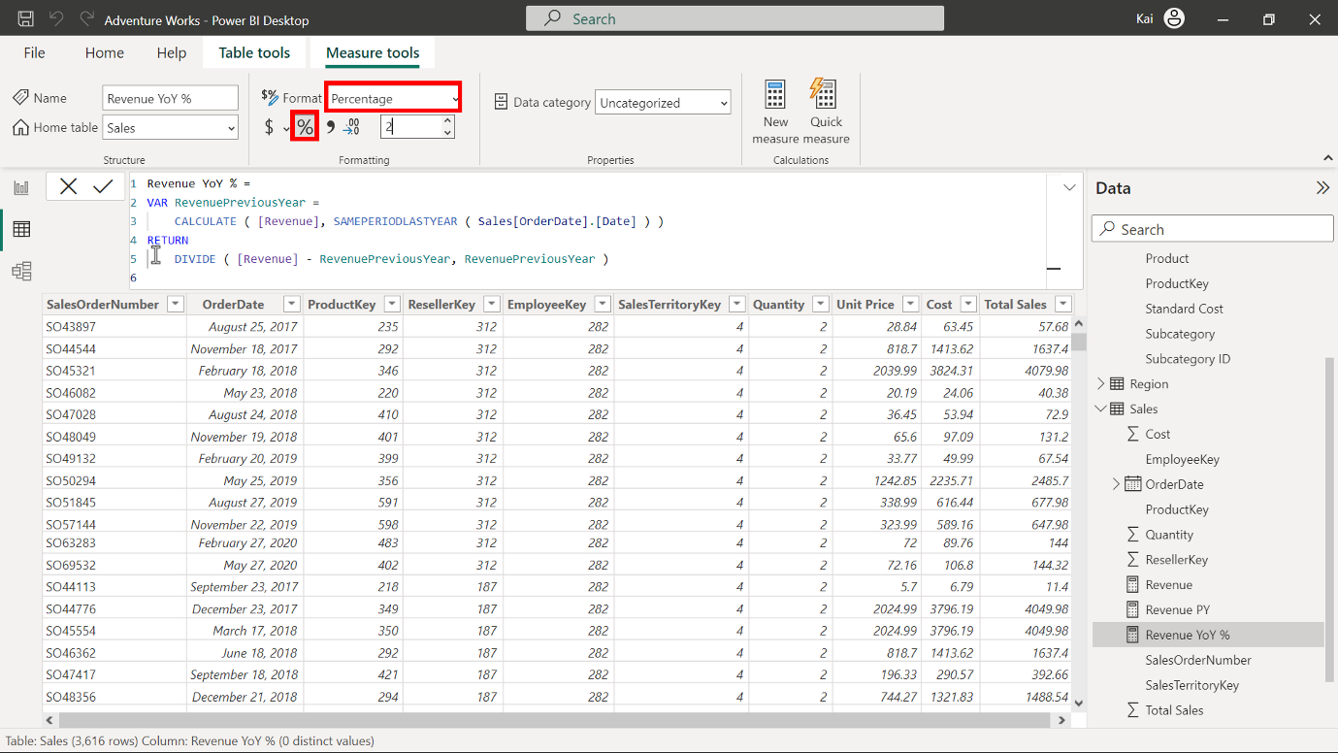

**Step 4: Update the matrix in Power BI report view with the measure results.**

1. Navigate to the **Report view** of Power BI desktop.

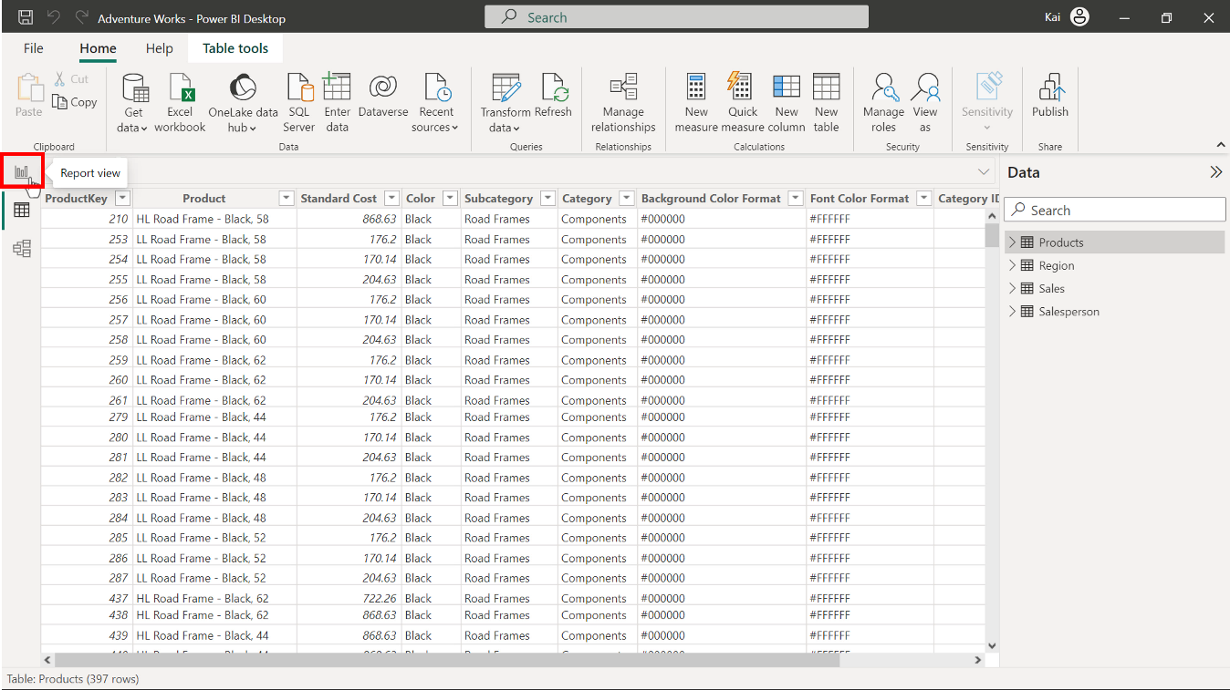

A premade matrix is present with a **Year** and **Month** column.

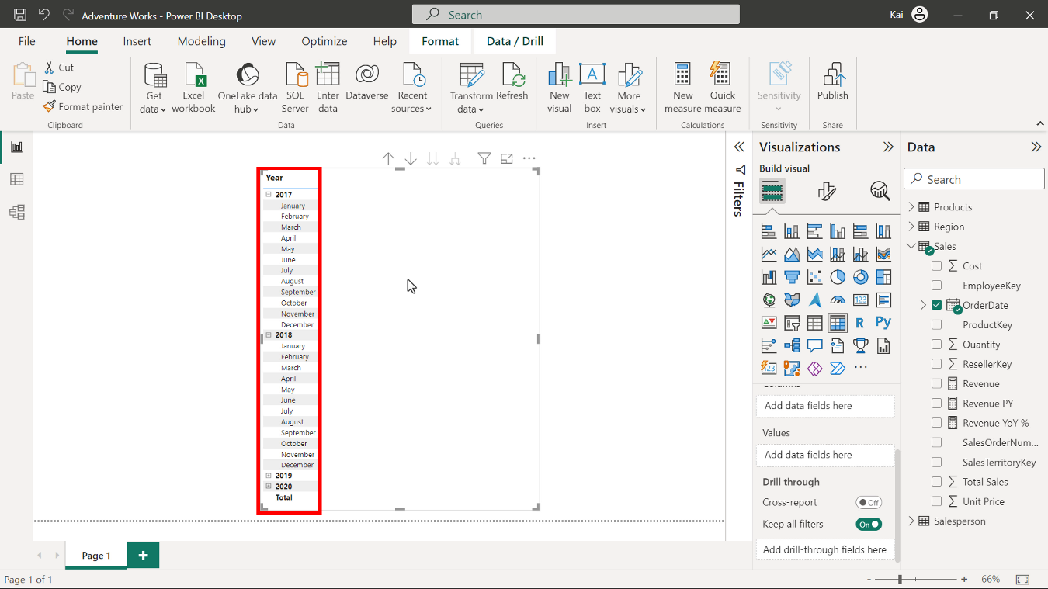

Bring the **Revenue**, **Revenue PY** and **Revenue YoY %** measures you have created to the matrix under the **Values** section.

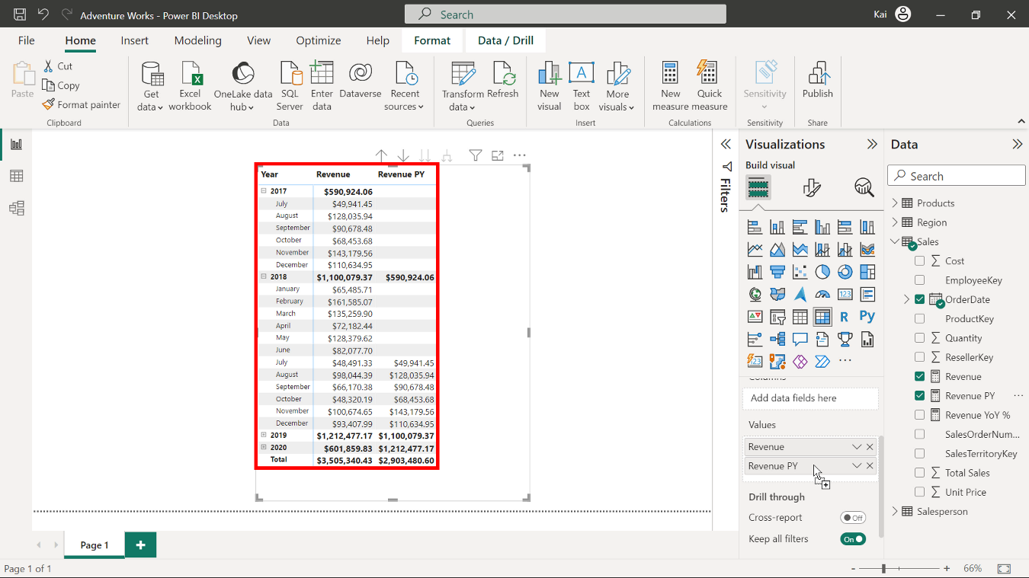

1. Note the values in all columns of the matrix. You can expand the **Year** by selecting the **plus** sign on the left side of the Year **column** in the matrix. A matrix view of the measure’s results is visible in the diagram below.

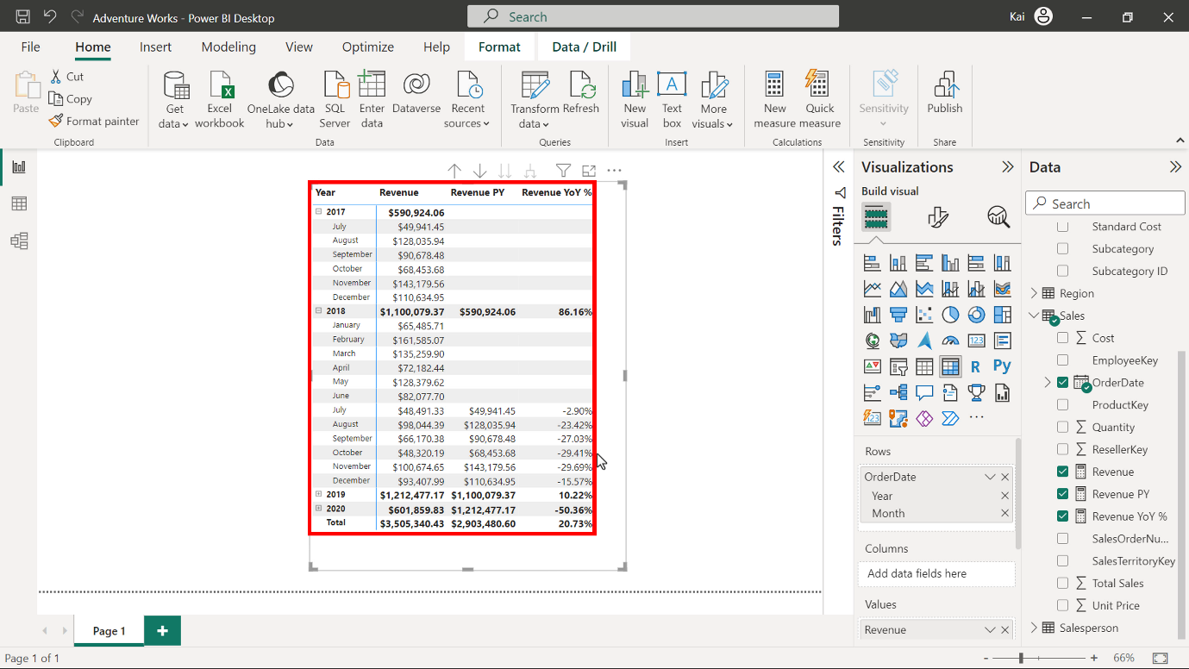

**Step 5: Save the Power BI project.**

* To save your Power BI project, open the **File** menu, select **Save As**, and provide an appropriate name for the project along with a path to the folder on your computer.

**Conclusion**

With these steps, you have successfully created measures to help Adventure Works analyze its data based on its analytical and business requirements and proven your capabilities with time intelligence functions.

Remember that when using DAX formulas, always ensure they are correctly formatted and that the column names match the actual column names in your data.